Component Analysis

Year: 2025 Semester: Spring Team: 10 Project: Smart Card Shuffler
Creation Date: February 4, 2025 Last Modified: February 7, 2025

Member 1: Krish Kumar | Email: kumar585@purdue.edu
Member 2: Craig Eagleburger | Email: ceaglebu@purdue.edu
Member 3: Brendan McLaughlin | Email: btmclaug@purdue.edu
Member 4: Johnny Hazboun | Email: jhazboun@purdue.edu

Assignment Evaluation: See Rubric on Brightspace Assignment

1.0 Component Analysis:

The four major components of our design analyzed in this document are the STM32 F7, Raspberry Pi, stepper motor, and power supply.

The STM32 F7 is the microcontroller responsible for the operation behind each part of the shuffler, including driving the motors and communicating with the Rasbperry Pi via UART.

The Raspberry Pi is an essential component as it processes the camera image to detect cards and communicates with the Flutter App via BLE.

We will be using one 17HE19-2004S NEMA 17 stepper motor from Stepper Online to rotate the wheel of cards. It will be controlled by a TMC2209 V1.3 stepper motor driver with a breakout board from BIGTREETECH.

Power Supply Unit: The power supply unit (PSU) is an essential component in any project as it is responsible for converting AC power to DC power.

1.1 Analysis of Component 1:
For our senior design project, we evaluated multiple power supply options to determine the most suitable unit. To select the optimal PSU, we compared three candidates based on specifications such as wattage, efficiency certification, modularity, and protection features. Below is a comparison of the power supplies:

Specification | ARESGAME AGV 500W | EVGA 500 W1 500W | Corsair CV550 550W
Wattage | 500W | 500W | 550W
Efficiency Rating | 80 Plus Bronze | 80 Plus White | 80 Plus Bronze
Modularity | Non-Modular | Non-Modular | Non-Modular
Protection Features | OVP, UVP, OPP, SCP | OVP, UVP, OPP, SCP | OVP, UVP, OPP, SCP
Warranty | 5 Years | 3 Years | 3 Years
Price | $37.99 | $49.99 | $59.99

Design Considerations:
- Efficiency and Power Stability: The ARESGAME AGV 500W PSU is 80 Plus Bronze certified, ensuring an efficiency of at least 85% under typical loads. A higher efficiency means it reduces heat generation and improves power stability.
- Protection Features: All three units offer over-voltage protection (OVP), under-voltage protection (UVP), over-power protection (OPP), and short-circuit protection (SCP), ensuring safe operation.
- Modularity: A non-modular PSU was chosen to keep costs low while providing necessary connectivity.
- Warranty and Cost: The ARESGAME AGV 500W PSU offers a 5-year warranty compared to 3 years for the alternatives while being the most cost-effective at $37.99.

1.1 Analysis of Component 2:

For our project we needed to select a computer / processor able to handle image processing, non trivial algorithms, and some form of bluetooth connection with our devices. Below is a comparison for some of the devices:

Device | Raspberry Pi Zero W | Raspberry Pi 4 | STM32WB55RG | Arduino Uno R4 Wifi
Price ($) | 15 | 35 | 36 | 22
Complexity (Scale of 10, 1 highest) | 6 | 7 | 3 | 5
Compatibility (Scale of 10, 10 most compatible) | 8 | 8 | 8 | 4
Size (Scale of 10, 10 smallest) | 8 | 3 | 9 | 3
Programming Language Compatibility | Many+ | Many+ | C | Arduino
Documentation (Scale of 10) | 8 | 9 | 6 | 8

Based on these ratings and information, we were able to conclude a Raspberry Pi Zero W is the best component for image processing and communication with mobile device. The Arduino does not allow for much flexibility and is not compatible with many languages, hence will be hard to implement. The STM32WB55RG while is a great device, due to it being not as commonly used, it does not have as much documentation / tutorials available online. Furthermore, it is only compatible with C which would make some processes harder to achieve. Between the Raspberry Pi 4 and Zero W, the Zero W is considerably smaller and hence is much easier to integrate within out PCB, and has enough computation power for our needs. Based on these reasons, we decided to integrate a Raspberry Pi Zero W into our system.

1.1 Analysis of Component 3:

In selecting the appropriate microcontroller for this project, the team took two main steps. The first was to decide which brand of microcontroller to use. We considered only two options, the ESP32 line of microcontrollers and the STM32 line.

 | ESP32 | STM32
Architecture | RISC-V | ARM32
Ports | Fewer GPIO (generally) | More GPIO (generally)
Industry Usage | Low | High
Existing Support | Growing but limited | Well established support
Team Experience | One team member | All team members
From this analysis the team mainly focused on the industry usage and the team experience. We wanted to gain more project experience with a microcontroller that we were likely to use in industry, and our familiarity with the basics of STM32 from ECE362 led us to the conclusion that we would be able to spend our time more productively learning and using and STM32 MCU.

Following this decision, the team needed to select a specific MCU from the STM32 lineup. We mainly referenced the below chart:
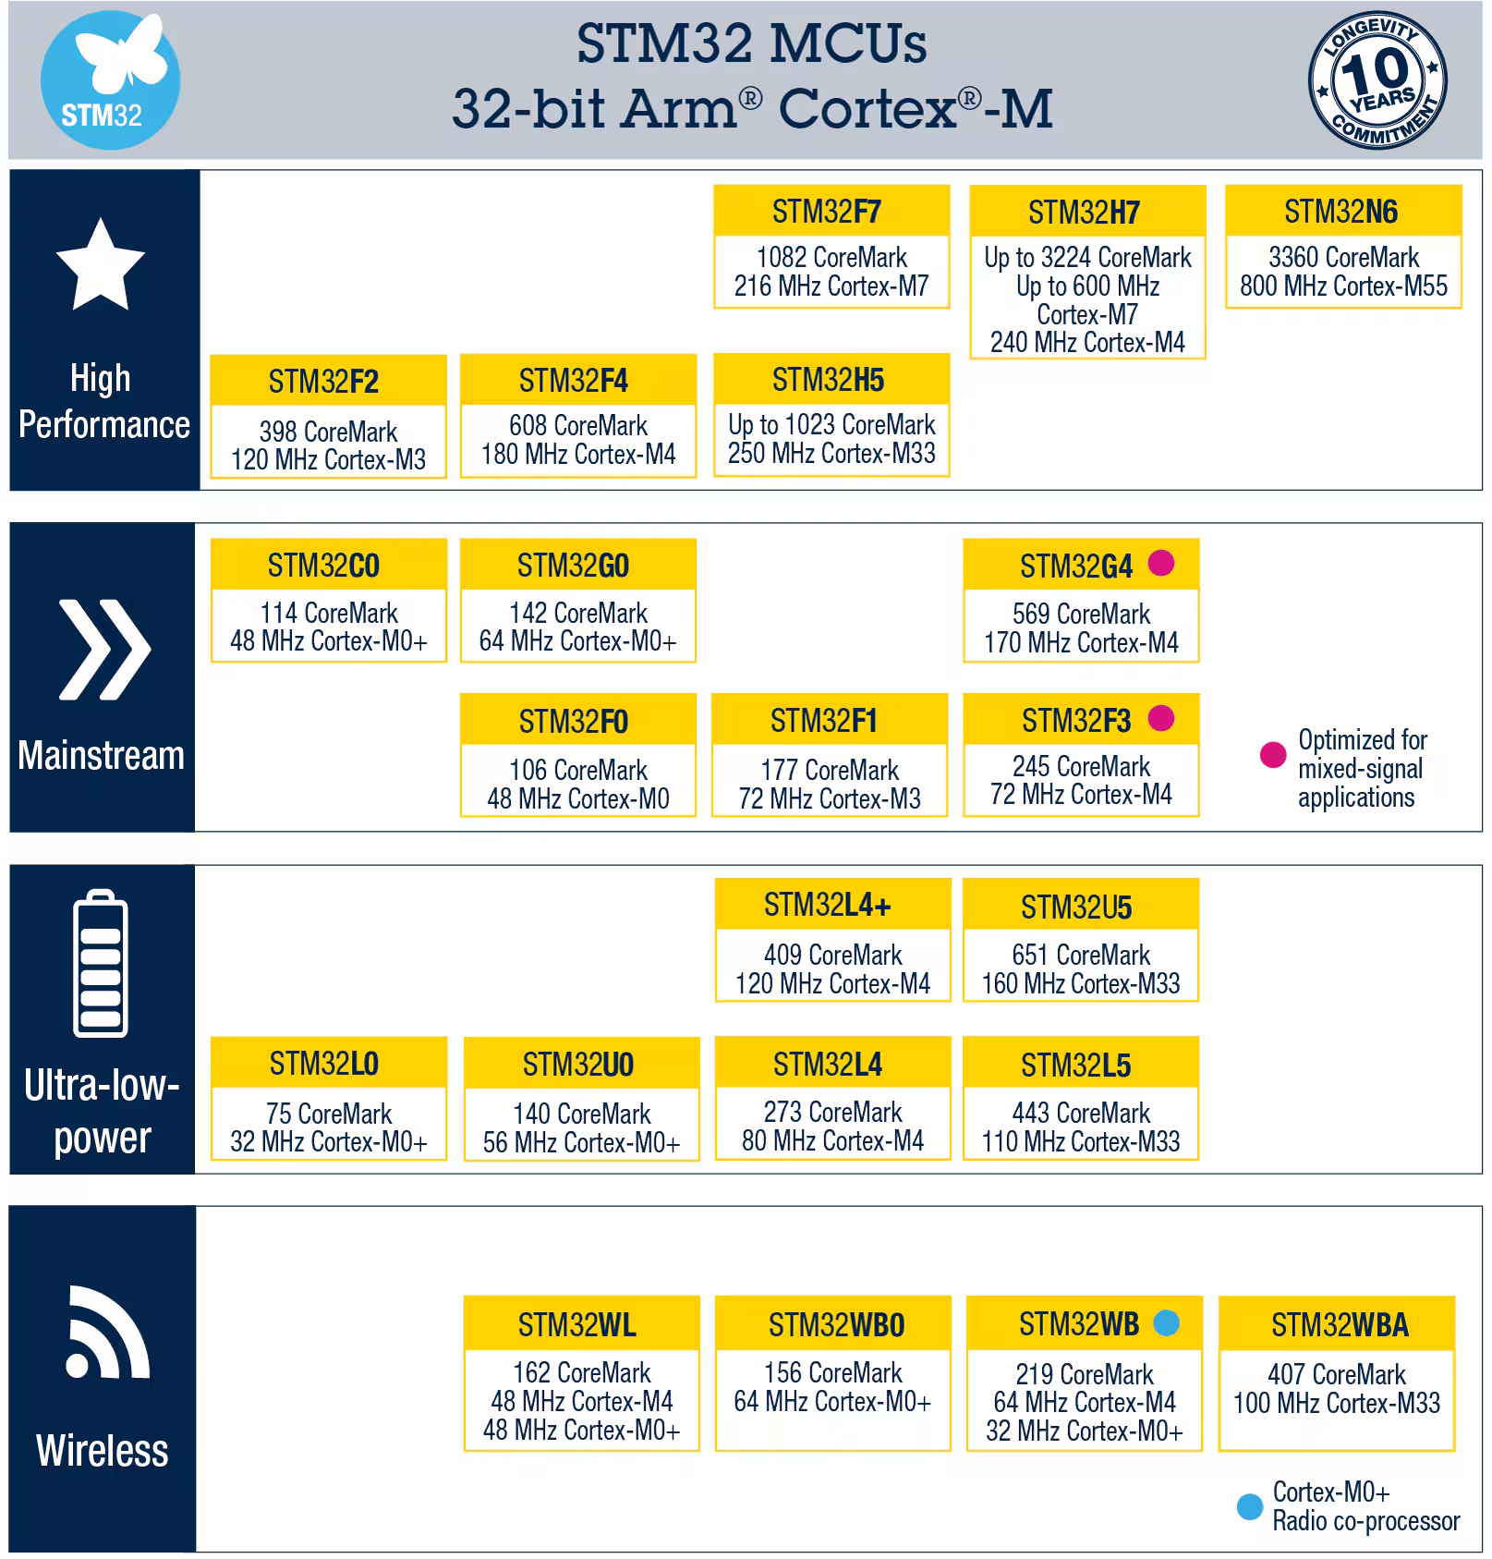
Given that for our project the only main functionality of the MCU is to control the motor drivers and use the card sorting algorithm to efficiently order the cards when entering/exiting the sorting mechanism, the wireless ability was not an important deciding factor. (The Raspberry Pi as discussed will be providing this feature.) Since the MCU will exist within a system containing high-power motors, low-power usage is not an important metric either. The team’s main concern for the MCU at this stage was the ability to properly execute the algorithm without the use of an external computer, so as such we sought out a higher-performance chip. Ultimately, the team selected the STM32F7 as our MCU of choice, as it is the highest-performing member of the F-series of MCUs with a clock speed of 215MHz. While higher performance options exist, they are not within the F-series of MCUs, which is the most mainstream line that ST offers. Since the team has previous experience with the F0 in ECE362, we decided the best option would be to stay within the same line but acquire as much extra power as possible to ensure the algorithm can be properly run.

1.1 Analysis of Component 4:

The wheel of the card shuffler requires a motor with a full range of motion, precise position control, and speed. The main options that can provide this functionality are continuous rotation servo motors and stepper motors.

 | Low End Servo | Mid Range Servo | Stepper Motor
Price | $12 | $133 (motor/driver combo) | $8.53 + $6.94 (driver)
Material | Plastic | Metal | Metal
Complexity | Low - PWM control | Medium - motor driver | High - homing sequence, motor driver
Power Consumption | Low | High | Medium
Strength | 44.52oz.in stall torque | 2NM holding torque | 77.88oz.in holding torque

Statistics about the low end servo are based on the FeeTech FS5103R [9]. The mid range servo is based on Cloudray Leadshine Hybrid Servo Motor Combo HBS57 [10]. The stepper motor is based on the 17HE19-2004S from Stepper Online [11]. The driver is BIGTREETECH TMC2209 V1.3 Stepper Motor Driver [12].

We decided on the 17HE19-2004S from Stepper Online. This was the best balance between robust build quality, strength and price. The low end servo would have been cheaper, but stability is non-negotiable in our project. The more robust build and added strength of the stepper are necessary. This will add some complexity compared to servos, since the motor will need to be homed for reliable position control.

This particular stepper motor was chosen due to its power rating, size, and brand reliability. This motor is rated for 2A per phase. This means we can limit the current to anything up to 2A. This is on the higher end of motors of this kind, allowing us the option to trade power efficiency for more torque. It is a NEMA 17 stepper motor, meaning it has a 1.7in x 1.7in faceplate. This is a very common size of stepper motor, and is appropriate for the size of our wheel. We decided on a 2A NEMA 17 stepper motor from Stepper Online because it is a very commonly used company. There are other Stepper Online motors in the cabinet in the lab.

2.0 Sources Cited:

[1] “Raspberry Pi Documentation - Computers,” www.raspberrypi.com. https://www.raspberrypi.com/documentation/computers/
[2] “STM32WB55RG - STMicroelectronics,” STMicroelectronics, 2023. https://www.st.com/en/microcontrollers-microprocessors/stm32wb55rg.html
[3] “Arduino® UNO R4 WiFi,” Arduino Online Shop, 2023. https://store-usa.arduino.cc/products/uno-r4-wifi?srsltid=AfmBOorSIWC_CEth4BKpIZsnFKYEyuECZrvHrqeAu0H-FDg5BLB7K7JV
[4] ARESGAME, "AGV Series 500W Power Supply, 80 Plus Bronze Certified, Non Modular Power Supply, 5 Year Warranty," Amazon, 2025. Available: https://www.amazon.com/ARESGAME-Supply-Certified-Modular-Warranty/dp/B0BDCKFJJT. [5] CORSAIR, "CORSAIR CV550, 80 PLUS Bronze, Semi-Modular Low-Noise ATX Power Supply," Amazon, Available: https://www.amazon.com/CORSAIR-Bronze-Modular-Low-Noise-Supply/dp/B0CQMQY2V2.
[6] EVGA, "EVGA 500 W1, 80+ WHITE 500W, 3 Year Warranty, Power Supply," Amazon, Available: https://www.amazon.com/EVGA-WHITE-Warranty-Supply-100-W1-0500-KR/dp/B00H33SFJU.
[7] “ESP32 vs STM32: Which is Better and How to Choose 2024,” Lisleapex.com. Accessed 2/8/2025. [Online] Available: http://lisleapex.com/blog-esp32-vs-stm32-which-is-better?srsltid=AfmBOoppM9BwLxsI1HSVKPpMFvN4ueBOHk7-Zdc7uCLbOYlNu6e_LmH6#title-esp32-vs-stm32-differences-between-esp32-and-stm32
[8] “STM32 32-Bit ARM Core MCUs,” ST.com. Accessed 2/8/2024. [Online] Available: https://www.st.com/en/microcontrollers-microprocessors/stm32-32-bit-arm-cortex-mcus.html
[9] “Continuous Rotation Servo - FeeTech FS5103R,” Adafruit. https://www.adafruit.com/product/154?gQT=1
[10] “Cloudray Leadshine Hybrid Servo Motor Combo HBS57,” CloudRay.
https://www.cloudraylaser.com/products/cloudray-leadshine-hybrid-servo-motor-combo-hbs57
[11] “E Series Nema 17 Bipolar 55Ncm(77.88oz.in) 2A 42x42x48mm 4 Wires w/ 1m Cable & Connector,” StepperOnline. https://www.omc-stepperonline.com/e-series-nema-17-bipolar-55ncm-77-88oz-in-2a-42x48mm-4-wires-w-1m-cable-connector-17he19-2004s
[12] “BIGTREETECH TMC2209 V1.3 Stepper Motor Driver,” BIQU. https://biqu.equipment/products/bigtreetech-tmc2209-stepper-motor-driver-for-3d-printer-board-vs-tmc2208

